Influence of Contralateral Routing of Signals (CROS) on Hearing Abilities of Different Groups of Cochlear Implant Users

Project ID: ABIntl-17-14

Clinical Investigation Plan
Version 0.5

Contact information

Sponsor | Advanced Bionics AG.  Laubisrütistrasse 28, CH-8712 Stäfa
Production site | Advanced Bionics LLC  25815 Westinghouse Place  USA-Valencia, CA 91355
Study Responsibility | Dr. Volkmar Hamacher  Advanced Bionics GmbH  European Research Center  Feodor-Lynen-Straße 35  D-30625 Hannover
Principal Investigator | Dr. Thomas Wesarg  Universitätsklinikum Freiburg  HNO-Klinik, Sektion Cochlear Implant  Elsässer Straße 2n  D-79110 Freiburg

CIP approval page

Study title: | Influence of Contralateral Routing of Signals (CROS) on Hearing Abilities of Different Groups of Cochlear Implant Users
Study compliance: | ISO 14155:2011, 90/385/EEC  ICH-GCP and Declaration of Helsinki
AB Study Number / CIP Number: | ABIntl-17-14

Protocol Commitment – Signatures
We have read and understood this protocol and agree on its content. We agree to conduct the study in accordance with the compliance and commitments as stated in this protocol. In addition, the signatories of this protocol (below) and delegates will assume responsibility for protocol compliance for persons to whom they delegate study related tasks. This document is the property of AB AG. It is at confidential disposal to the study participants. It may not be used, divulged, published or otherwise disclosed without the consent of the Principal Investigator and Advanced Bionics AG. (Please Use blue ink)

Name of Principal Investigator, Freiburg:
Date: |  | Signature:
Name of Global Vice President Research and Technology, Hannover:
Date: |  | Signature:

Clinical Investigation Synopsis
Study Title | Influence of Contralateral Routing of Signals (CROS) on Hearing Abilities of Different Groups of Cochlear Implant Users
Sponsor | Advanced Bionics AG, Switzerland
Device | Naída CI Q90 sound processor, Naída Link hearing aids and Naída Link CROS
Study Design | Within subject comparison
Regulatory Objective | Post-market study
Study Population | 40 adult CI users and 10 adult normal hearing listeners as reference group
Inclusion Criteria | - Unilateral group: CII, HiRes90K, HiRes90K Advantage or HiRes Ultra implant system on one side  - Bimodal group: CII, HiRes90K, HiRes90K Advantage or HiRes Ultra implant system on one side and hearing aid contralaterally  - Bilateral group: CII, HiRes90K, HiRes90K Advantage or HiRes Ultra implant system on both sides  - Minimum of 18 years of age  - Minimum of six months experience with their hearing devices  - 65% speech recognition for the OlSa in quiet at 65 dB SPL with CI only (1st side)  - German language proficiency  - Ability to provide subjective feedback on sound quality and speech understanding
Exclusion Criteria | - Difficulties additional to hearing impairment that would interfere with the study procedures.
Primary Study Objective | The primary objective of this study is to compare the speech intelligibility with one CI and the contralateral CROS device to the speech intelligibility with CI and unaided contralateral side in the presence of speech shaped noise.
Primary Study Measure | Difference in the speech reception threshold (SRT) in the OlSa in presence of speech shaped noise between CI only and CI + CROS, measured in dB SNR.
Secondary Study Objective | To compare speech intelligibility and localization abilities between CI only and CI + a second hearing instrument (CI, HA or CROS)
Secondary Study Measure | Difference in speech reception threshold in dB for speech intelligibility and localization error for localization abilities, measured in dB SNR and degree, respectively, between CI only and CI + a second hearing instrument (CI, HA or CROS)
Study Schedule | December 01, 2017 to November 30, 2018
Study Monitoring | Advanced Bionics GmbH, European Research Center
Statistical Analysis | Co-operation Universitätsklinikum Freiburg and Advanced Bionics

Table of Contents

1. Study Overview 7
1.1. Purpose of the Investigation 7
1.2. Device Innovation 7
1.2.1. Sound Processor 7
1.2.2. CROS 8
1.2.3. Hearing Aid 8
1.2.4. UltraZoom 9
1.2.5. StereoZoom 9
1.3. Intended Purpose of the Investigational Device in the Proposed Clinical Investigation 9
1.4. Duration of the Study 9
2. Study Protocol 10
2.1. Study Design 10
2.2. Inclusion and exclusion criteria 10
2.3. Withdrawal, Discontinuation, and Replacement of Subjects 11
2.4. Treatment Plan, Insurance and Compensation 12
2.5. Procedures 12
2.5.1. Recruitment 12
2.5.2. Screening Procedures 12
2.5.3. Consent 12
2.5.4. Enrolment 13
2.5.5. Study Schedule 13
2.5.6. Unscheduled Visits 17
2.5.7. Subject Care After Study Completion 17
2.5.8. Measures 17
2.5.9. Fitting of hearing devices 19
2.6. Study Objectives and Assessments 19
2.6.1. Study Primary Endpoint Assessment 19
2.6.2. Study Secondary Endpoint Assessment 19
2.6.3. Additional Interest Assessment 20
2.7. Statistical Methods 20
2.7.1. General Considerations 20
2.7.2. Analyses 20
2.7.3. Sample Size Justification 20
3. Risk Analysis 21
3.1. Adverse Event Reporting 21
4. Ethical and Regulatory Responsibilities 22
4.1. Study Conduct 22
4.2. Ethical committee 22
4.3. Informed Consent Form 23
4.3.1. Informed Consent Form 23
4.3.2. Subject Enrollment 23
4.4. Amendments and Deviations 23
4.4.1. Protocol Amendments 23
4.4.2. Emergency Deviations 23
4.5. Documents and Records 24
4.5.1. Pre-Study Documentation Requirements 24
4.5.2. Study Documentation/Case Report Forms 24
4.5.3. Protocol Deviations 24
4.6. Study Monitoring 24
4.6.1. Device Accountability 25
4.6.2. Record Retention 25
4.6.3. Inspection of Records 25
4.7. Suspension and Termination 25
4.7.1. Criteria for Suspending or Terminating a Study Site 25
4.8. Investigator Responsibilities 25
5. Monitoring Procedures 26
5.1. Site Initiation Training 26
5.2. Interim Monitoring Activities 26
5.3. Close-Out Monitoring Activities 27
5.4. Management of Site Noncompliance 27
5.5. Documentation and Records 27
6. Data Management 28
6.1. Data collection 28
6.2. Data processing 28
7. Contractual binding documents 28
8. Publication 28
9. References 28

List of Abbreviations
AB Advanced Bionics
AE Adverse Event
BTE Behind-the-Ear
CI Cochlear Implant
CIP Clinical Investigation Plan
CRF Case Report Form
CROS Contralateral Routing Of Signals
dB Decibel
HA Hearing Aid
ICF Informed Consent Form
QST Questionnaire
RES Real Ear Sound
RIC Receiver-in-the-Canal
SAE Serious Adverse Event
SNR Signal-to-Noise Ratio
SP Sound Processor
SPL Sound Pressure Level
SRT Speech Reception Threshold
SZ StereoZoom
UP UltraPower
UZ UltraZoom

- Study Overview
  - Purpose of the Investigation
For cochlear implant (CI) as well as hearing aid (HA) users understanding speech in noisy listening conditions remains a challenge. One effective method to improve the signal-to-noise ratio (SNR) – and thus speech intelligibility – in such conditions is the use of directional microphones. Directional microphones (also called beamformers) attenuate sounds from the back hemisphere and to the side of the listener while maintaining signals from the front so that a speaker in front of the listener becomes easier to understand. Adaptive beamformers are able to adapt their maximal attenuation depending on the position of the noise source(s). Furthermore, frequency specific attenuation can be achieved which is useful if several noise sources with different frequency characteristics and locations are present. Compared to adaptive (monaural) beamformers the binaural beamformers are narrowing the focus by creating a bi-directional network between two hearing devices. These beamformers have already proven useful in hearing aid as well as cochlear implant users (Ricketts and Henry 2002; Bentler et al. 2004; Dillon 2012; Geissler et al. 2015).
For patients with no residual hearing bilateral implantation has been shown to provide substantial benefits in speech understanding compared to unilateral cochlear implantation (Summerfield et al. 2006; Brown and Balkany 2007). The second hearing device helps overcoming the head shadow effect (Litovsky et al. 2006; van Hoesel et al. 2008). However, for a variety of reasons some CI users cannot receive a second CI. Due to the high costs the second implant cannot be reimbursed in all countries (Summerfield et al. 2002) by health care systems. Medical reasons can also be a contraindication for a second CI surgery. With contralateral routing of signals (CROS) devices there is an alternative for this unilateral CI user group, overcoming the head shadow effect by streaming the signal from the contralateral side to the CI.
Advanced Bionics in combination with Phonak provides a variety of hearing solutions for different groups of hearing impaired patients: bilaterally deafened with either two implants or one implant and one CROS device, bilaterally hearing impaired, but only one side severe to profound, with one implant and one hearing aid. The different hearing devices, naming Naída CI, Naída Link CROS and Naída Link hearing aid, are compatible and provide the same directional microphone technology, naming UltraZoom (adaptive beamformer) and StereoZoom (binaural beamformer).
The purpose of this investigation is to evaluate the influence of the different devices and microphone technologies for different CI user groups in terms of speech performance as well as sound quality and localization.
  - Device Innovation
The Naída CI sound processor was introduced into the market in 2013 providing the directional microphone technology for unilateral as well as bilateral CI users, whereas bilateral CI users benefit from the direct communication between the two devices. In 2016 the Naída Link hearing aid was market approved giving access to the same technologies for unilateral CI users with contralateral aidable residual hearing. The Naída Link CROS was introduced into the market in 2017 aiming for unilateral CI users with severe to profound hearing loss contralaterally and no immediate possibility for a second implant.
    - Sound Processor
The Naída CI sound processor (Figure 1) designed by Advanced Bionics offers different microphone options. Two omni-directional microphones are available: one is located on the processor (BTE microphone), the second one, named T-Mic is connected to the external input of the processor and located at the entrance of the ear canal (Buechner et al. 2005). The T-Mic is an accessory which is used instead of an earhook. This position gives CI users access to the frequency response of the pinna as well as an attenuation of noise from the back. The Naída CI sound processor provides in addition the adaptive beamformer UltraZoom (UZ) and the binaural beamformer StereoZoom (SZ) by using the directional microphones of both devices.
The sound processor will be fitted with the clinical fitting software SoundWave.
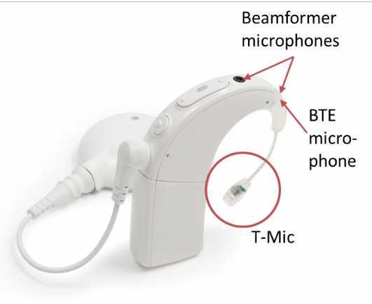 | Figure 1: Picture of the Naída CI processor
    - CROS
The Naída Link CROS device (Figure 2) is designed by Phonak to stream signals wirelessly to the CI sound processor. The Naída Link CROS provides an omni-directional microphone as well as the adaptive beamformer UltraZoom (UZ) and the binaural beamformer StereoZoom (SZ).
The CROS device will be programmed within the clinical fitting software SoundWave.
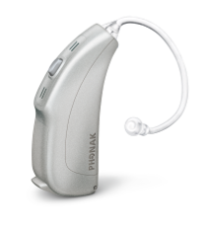 | Figure 2: Picture of the Naída Link CROS
    - Hearing Aid
The Naída Link hearing aid (Figure 3) designed by Phonak is available in two configurations: Naída Link UltraPower (UP) and Naída Link Receiver-in-the-Canal (RIC). The Naída Link UP offers a maximum output power of 142 dB SPL (2 cc coupler) and maximum gain of 82 dB in the frequency range of <100 up to 4,900 Hz. The Naída Link RIC offers a maximum output power of 126 dB SPL (2 cc coupler) and maximum gain of 55 dB in the frequency range of <100 up to 6,200 Hz.
The Naída Link hearing aid provides an omni-directional microphone as well as the adaptive beamformer UltraZoom (UZ) and the binaural beamformer StereoZoom (SZ).
The hearing aid will be fitted with the clinical fitting software Phonak Target.

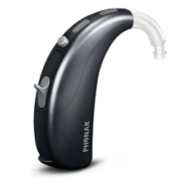 | 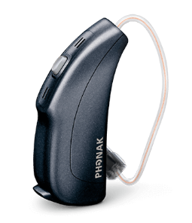 | Figure 3: Picture of the Naída Link hearing aid in its UltraPower (UP, left) and receiver-in-the-canal (RIC, right) configuration

    - UltraZoom
UltraZoom is an adaptive multi-channel (working independently in 33 bands) beamformer. Due to their placement the two spatially separated microphones are picking up the signal with time and therefore phase differences. With this technique a reduced sensitivity in a certain direction can be used to attenuate the signals in the back hemisphere. UltraZoom follows dynamically the direction of the noise incidence with a speed of 90° in 100 ms in a range of 60° to 300°. This feature is working similarly on the Naída CI sound processor, the Naída Link CROS device and on the Naída Link hearing aid.
    - StereoZoom
StereoZoom is a binaural beamformer, which has a static directional microphone system. In the first stage, the input signals of both microphones in both hearing devices are used to calculate a standard dual microphone system. The respective output signal of the microphone system is sent to the contralateral side using wireless transmission. It is then processed together with the output signal of the ipsilateral dual microphone system, using a weighting function. Compared to UltraZoom this beamformer provides a narrower main lobe of the directional characteristic in a range of 45° to 315°. In addition, there is an increased attenuation of all signals that do not come from the front and are interpreted and suppressed as noise signals. Like the UltraZoom beamformer, StereoZoom is available for all three devices under investigation.
  - Intended Purpose of the Investigational Device in the Proposed Clinical Investigation
The devices will be used according to their intended purpose within this clinical investigation. All soft- and hardware is CE-marked.
  - Duration of the Study
The duration of the clinical study for each subject will last from one month up to six months. The study will last 12 months in total.
- Study Protocol
  - Study Design
An un-controlled open design with within-subject comparisons will be used. Each of the 40 subjects will visit the clinic twice over the course of the study, while the first appointment lasts one day and the second appointment two days. Measurement time will last approximately three hours per appointment. During the appointments in the clinic speech intelligibility in quiet as well as in noise and localization abilities will be tested. Subject’s feedback regarding sound quality and speech understanding as well as descriptive feedback will be collected. As a reference group 10 normal hearing subjects will be tested using the same speech intelligibility and localization tests.
  - Inclusion and Exclusion Criteria
Bilateral CI user group (N = 10):
Inclusion criteria:
- Minimum of 18 years of age
- Minimum of six months experience with their hearing devices
- 65% speech intelligibility for the OlSa in quiet at 65 dB SPL with CI only on the first implanted side
- German language proficiency
- Ability to provide subjective feedback on sound quality and speech understanding
- CII, HiRes90K, HiRes90K Advantage or HiRes Ultra implant system on both sides; first implanted ear is defined as 1st side, the second implanted ear is defined as 2nd side
- Naída CI Q70 or Q90 sound processors on both sides
Exclusion criteria:
- Difficulties additional to hearing impairment that would interfere with the study procedures.
Unilateral CI user group (N = 10):
Inclusion criteria:
- Minimum of 18 years of age
- Minimum of six months experience with their hearing device
- 65% speech intelligibility for the OlSa in quiet at 65 dB SPL with CI only
- German language proficiency
- Ability to provide subjective feedback on sound quality and speech understanding
- CII, HiRes90K, HiRes90K Advantage or HiRes Ultra implant system on one side
- Naída CI Q70 or Q90 sound processor
- Contralaterally unaided
- Contralateral unaided hearing thresholds > 90 dB at frequencies from 125 to 8,000 Hz
Exclusion criteria:
- Difficulties additional to hearing impairment that would interfere with the study procedures.
Bimodal CI user group (N = 20):
Inclusion criteria:
- Minimum of 18 years of age
- Minimum of six months experience with their hearing devices
- 65% speech intelligibility for the OlSa in quiet at 65 dB SPL with CI only
- German language proficiency
- Ability to provide subjective feedback on sound quality and speech understanding
- CII, HiRes90K, HiRes90K Advantage or HiRes Ultra implant system on one side
- Naída CI Q70 or Q90 sound processor
- Contralateral hearing aid
- Bimodal sub-group I (N = 10): contralateral unaided hearing thresholds ≤ 90 dB at frequencies > 750 Hz and < 6 kHz
- Bimodal sub-group II (N = 10): contralateral unaided hearing thresholds > 90 dB on at least one frequency > 750 Hz and < 6 kHz
Exclusion criteria:
- Difficulties additional to hearing impairment that would interfere with the study procedures.
Normal hearing reference group (N = 10):
Inclusion criteria:
- Minimum of 18 years of age
- Hearing thresholds (air conduction) of less than 20 dB for all frequencies up to 8 kHz
- German language proficiency
Exclusion criteria:
- Difficulties that would interfere with the study procedures
- Any history of hearing impairment
- Use of any hearing devices
  - Withdrawal, Discontinuation, and Replacement of Subjects
Subjects may withdraw from the study at any time, with or without reason, and without affecting continued standard of medical care they would receive. Subjects can be discontinued from the study for the following reasons:
- Withdrawal of consent
- A safety concern noted by a clinician that endangers the subject or cannot be tolerated for medical and/or ethical reasons
- Inability of the subject to perform the tasks necessary to provide usable data for the study
- Failure to attend a follow-up visit after three documented attempts to contact the subject and reschedule the visit.
Subjects who withdraw or who are discontinued prior to the completion of the second visit will be replaced. Unless formal withdrawal of consent and written wish not to use the subject’s data, all data gathered as per protocol will be used in the analysis. Subjects who withdraw or who are discontinued from the study will be reported on the appropriate Case Report Form. These subjects will continue to receive standard medical care.
The Investigator (or authorized delegate) in cooperation with the study monitor will complete a log to document the disposition of each enrolled subject (completed study, withdrew, discontinued).
Any premature termination by the subject must be documented. All attempts must be made to observe the subject and to continue documentation until conclusion of the study or resolution of an (S)AE.
  - Treatment Plan, Insurance and Compensation
In the unlikely event that an injury occurs as a result of participating in this study, treatment will be provided or arranged by the investigator. Costs for an insurance covering injuries occurring on the travels to the center and back for study appointments will be covered by Advanced Bionics through HDI-Gerling insurances.
Advanced Bionics AG will compensate subjects for travel expenses associated with the follow ups which are not part of standard clinical practice at that investigational center. The center will be compensated for additional workload related to the study and costs for ethics submission will be covered by AB. Loaner devices will be provided by Advanced Bionics for the course of the study.
  - Procedures
    - Recruitment
Subjects who meet the inclusion criteria will be recruited from the adult patient population at the Universitätsklinikum Freiburg as well as at the Universitätsmedizin Mannheim. Normal hearing persons will be recruited from students of the Universities in Freiburg and its environs, from relatives of patients or from contacts of the study investigators. Excluded is the personal of the Universitätsklinikum Freiburg to avoid a dependency between the normal hearing subjects and the study center. The subjects will be informed about the study by posting, e-mail, mail, phone, fax letter or personally.
    - Screening Procedures
Subjects will be selected from the clinics patient pool based on their audiological data. Additionally, demographical data will be taken into account to confirm the inclusion criteria. Patients will be contacted by a notice, e-mail, ordinary letter, fax letter, phone or personally. Subject information will be sent to the patient prior to the baseline appointment.
    - Consent
Subjects who meet all of the criteria will be contacted. At the first appointment in the clinic, the study procedure will be discussed in all details and the subject will have the opportunity to ask questions. Afterwards the subject will be asked to sign the informed consent form including data release. Following the signature the subject will be considered to be enrolled in the study.
After receiving detailed information about the study procedure and having asked additional questions a subject may decide not to participate in the study. In that case Advanced Bionics will still cover his/her travelling costs. It will not have any influence on his/her further clinical treatment.

    - Enrolment
A subject is considered to be enrolled in the study only after informed consent is obtained. Once enrolled, the subject will be assigned a unique identifier. The identifier will consist of an alphanumeric sequence that will consist of a study identifier, the investigational site identifier and the sequential subject number, e.g. UKF-CROS-09 for subject 09 at the center UKF in the CROS study.
    - Study Schedule
Two study appointments are necessary for all CI user groups: appointments A (1 day) and B (2 days). All appointments will take place at Universitätsklinikum Freiburg.
During the appointments data obtained will be documented in the Case Report Forms (CRFs). The history will include demographic information (date of birth, history of hearing loss etc.). Section 2.5.6 details the tests and procedures administered at each study appointment. The study flow for the four CI user groups is shown in Table 1, for the normal hearing control group in Table 2. The tests will be conducted in a randomized order within one appointment. Unaided hearing thresholds will be measured at the beginning of the first test session to confirm the hearing status of the subjects.
Appointment A (1 day)
- Discussion of study procedure with the opportunity to ask questions
- Collection of signatures on the informed consent form including data release
- Completion of Custom QST all (rating of clinically used hearing devices) for all groups
- Speech perception in quiet in setup A (with their own processor)
  - Bilateral: CI only (1st side), CI only (2nd side), 1st CI + 2nd CI
  - Unilateral: CI only
  - Bimodal: CI only, HA only, CI + HA
- Speech perception in noise in setup B (with their own processor)
  - Bilateral: CI only (1st side), 1st CI + 2nd CI
  - Unilateral: CI only
  - Bimodal: CI only, CI + HA
- Unaided hearing threshold measurements on both sides (all groups)
- Aided hearing threshold measurements
  - Bilateral: CI only (1st side), CI only (2nd side), 1st CI + 2nd CI
  - Unilateral: CI only
  - Bimodal: CI only, HA only, CI + HA
- Fitting of own devices (take-home)
  - Bilateral: both Naída CI
  - Unilateral: Naída CI and loaner Naída Link CROS
  - Bimodal: Naída CI and (loaner) Naída Link HA (with bimodal fitting formula)
- Programming of loaner devices (acute testing)
  - Bilateral: two loaner Naída CI
  - Unilateral: loaner Naída CI and loaner Naída Link CROS
  - Bimodal: loaner Naída CI and loaner Naída Link HA (with bimodal fitting formula)
- Speech perception in noise in setup B
  - Bilateral: CI only (1st side), CI only (2nd side), 1st CI + 2nd CI
  - Unilateral: CI only, CI + CROS
  - Bimodal: CI only, HA only, CI + HA
- Speech perception in noise in setup C
  - Unilateral: CI only, CI + CROS
- Speech perception in noise in setup D (optional)
  - Unilateral: CI only, CI + CROS
- Collection of descriptive feedback during the appointment for all study groups
Take-home phase
- Minimum of 4 weeks adaptation time
  - Unilateral: adaptation to CROS device
  - Bimodal: adaptation to Naída Link HA (for non Naída Link HA users)
- Completion of SSQ-12 (comparison of currently used hearing devices and CI only)
- No adaptation required for bilateral CI users, therefore no minimum limitation for time period in between appointments
Appointment B – day 1
- Collection of SSQ-12 (comparison of currently used hearing devices and CI only)
- Completion of Custom QST all (rating of currently used hearing devices)
  - Bimodal: CI and Naída Link HA
- Completion of Custom QST uni (rating of the CROS device)
  - Unilateral: CI and CROS
- Programming of loaner devices (acute testing)
  - Bilateral: two loaner Naída CI
  - Unilateral: loaner Naída CI and loaner Naída Link CROS
  - Bimodal: loaner Naída CI and loaner Naída Link HA (with bimodal fitting formula)
- Aided hearing threshold measurements
  - Bilateral: CI only (1st side), CI only (2nd side), 1st CI + 2nd CI
  - Unilateral: CI only, CI + CROS
  - Bimodal: CI only, HA only, CI + HA
- Localization measurements
  - Bilateral: CI only (1st side), 1st CI + 2nd CI
  - Unilateral: CI only, CI + CROS
  - Bimodal: CI only, CI + HA
- Programming of devices for short-term take-home
  - Bilateral: own Naída CI (1st side) and loaner Naída Link CROS
  - Bimodal: own Naída CI and loaner Naída Link CROS
- Speech perception in noise in setups C and D
  - Bilateral: CI only (1st side), CI + CROS, 1st CI + 2nd CI
  - Unilateral: CI only, CI + CROS
  - Bimodal: CI only, CI + CROS, CI + HA
- Collection of descriptive feedback during the appointment for all study groups

Short-term adaptation
- Adaption to CROS device for bilateral and bimodal CI users
(Unilateral CI users keep the CROS device)
Appointment B – day 2
- Completion of custom QST all by all CI users
- Speech perception in noise in setup B
  - Bilateral: CI only (1st side) [omni], 1st CI + CROS [omni, UltraZoom (optional), StereoZoom], 1st CI + 2nd CI [omni, UltraZoom, StereoZoom]
  - Unilateral: CI only [omni, UltraZoom], CI + CROS [omni, UltraZoom, StereoZoom]
  - Bimodal I: CI only [omni], CI + CROS [omni, UltraZoom (optional), StereoZoom], CI + HA [omni, UltraZoom , StereoZoom]
  - Bimodal II: CI only [omni], CI + CROS [omni, UltraZoom, StereoZoom], CI + HA [omni, UltraZoom (optional), StereoZoom]
- Localization measurements
  - Bilateral: CI only (1st side), 1st CI + CROS, 1st CI + 2nd CI (opt.)
  - Bimodal: CI only, CI + CROS, CI + HA (opt.)
- Collection of descriptive feedback during the appointment for all study groups
- Switching subject of all study groups back to his or her clinically used programs and processor and/or hearing aid at the end of day 2
with CI user’s hearing devices | Bilateral |  |  | Unilateral |  |  | Bimodal I |  |  | Bimodal II
 | Appoint-ment A | Appoint-ment B1 | Appoint-ment B2 | Appoint-ment A | Appoint-ment B1 | Appoint-ment B2 | Appoint-ment A | Appoint-ment B1 | Appoint-ment B2 | Appoint-ment A | Appoint-ment B1 | Appoint-ment B2
Speech Perception
in Quiet S₀ [A]
CI only | omni [1st side] | x |  |  | x |  |  | x |  |  | x
CI only | omni [2nd side] | x
HA only | omni |  |  |  |  |  |  | x |  |  | x
1st CI + 2nd CI | omni | x
CI + HA | omni |  |  |  |  |  |  | x |  |  | x
in Noise S₀N_{-60:60} [B]
CI only | omni [1st side] | x |  |  | x |  |  | x |  |  | x
CI + CI | omni | x
CI + HA | omni |  |  |  |  |  |  | x |  |  | x
Hearing Thresholds
Aided
CI only | omni [1st side] | x |  |  | x |  |  | x |  |  | x
CI only | omni [2nd side] | x
HA only | omni |  |  |  |  |  |  | x |  |  | x
CI + CROS | omni
1st CI + 2nd CI | omni | x
CI + HA | omni |  |  |  |  |  |  | x |  |  | x
Unaided
both sides (individually) | x |  |  | x |  |  | x |  |  | x

with study loaner devices | Bilateral |  |  | Unilateral |  |  | Bimodal I |  |  | Bimodal II
 | Appoint-ment A | Appoint-ment B1 | Appoint-ment B2 | Appoint-ment A | Appoint-ment B1 | Appoint-ment B2 | Appoint-ment A | Appoint-ment B1 | Appoint-ment B2 | Appoint-ment A | Appoint-ment B1 | Appoint-ment B2
Speech Perception
in Noise S₀N_{-60:60} [B]
CI only | omni [1st side] | x |  | x | x |  | x | x |  | x | x |  | x
CI only | omni [2nd side] | x
HA only | omni |  |  |  |  |  |  | x |  |  | x
CI + CROS | omni |  |  | x | x |  | x |  |  | x |  |  | x
1st CI + 2nd CI | omni | x |  | x
CI + HA | omni |  |  |  |  |  |  | x |  | x | x |  | x
CI only | UltraZoom |  |  |  |  |  | x
CI + CROS | UltraZoom |  |  | (x) |  |  | x |  |  | (x) |  |  | x
1st CI + 2nd CI | UltraZoom |  |  | x
CI + HA | UltraZoom |  |  |  |  |  |  |  |  | x |  |  | (x)
CI + CROS | StereoZoom |  |  | x |  |  | x |  |  | x |  |  | x
1st CI + 2nd CI | StereoZoom |  |  | x
CI + HA | StereoZoom |  |  |  |  |  |  |  |  | x |  |  | x
in Noise S₊₆₀N_{120:0} [C]
CI only | omni [1st side] |  | x |  | x | x |  |  | x |  |  | x
CI only | omni [2nd side]
CI + CROS | omni |  | x |  | x | x |  |  | x |  |  | x
1st CI + 2nd CI | omni |  | x
CI + HA | omni |  |  |  |  |  |  |  | x |  |  | x
in Noise S₋₆₀N_{-120:0} [D]
CI only | omni [1st side] |  | x |  | (x) | x |  |  | x |  |  | x
CI only | omni [2nd side]
CI + CROS | omni |  | x |  | (x) | x |  |  | x |  |  | x
1st CI + 2nd CI | omni |  | x
CI + HA | omni |  |  |  |  |  |  |  | x |  |  | x
Localization [E]
CI only | omni [1st side] |  | x | x |  | x |  |  | x | x |  | x | x
CI + CROS | omni |  |  | x |  | x |  |  |  | x |  |  | x
CI + CI | omni |  | x | (x)
CI + HA | omni |  |  |  |  |  |  |  | x | (x) |  | x | (x)
Hearing Thresholds
Aided
CI only | omni [1st side] |  | x |  |  | x |  |  | x |  |  | x
CI only | omni [2nd side] |  | x
HA only | omni |  |  |  |  |  |  |  | x |  |  | x
CI + CROS | omni |  |  |  |  | x
1st CI + 2nd CI | omni |  | x
CI + HA | omni |  |  |  |  |  |  |  | x |  |  | x

with study loaner devices | Bilateral |  |  | Unilateral |  |  | Bimodal I |  |  | Bimodal II
 | Appoint-ment A | Appoint-ment B1 | Appoint-ment B2 | Appoint-ment A | Appoint-ment B1 | Appoint-ment B2 | Appoint-ment A | Appoint-ment B1 | Appoint-ment B2 | Appoint-ment A | Appoint-ment B1 | Appoint-ment B2
Subjective Feedback
Custom QST uni (absolute) |  |  |  |  | x
Custom QST all (compar.) | x |  |  | x |  |  | x |  |  | x
SSQ-12 |  | x |  |  | x |  |  | x |  |  | x
Descriptive feedback | x | x | x | x | x | x | x | x | x | x | x | x
Table 1: Study design for appointments A and B (1 and 2) for the four CI subject groups (unilateral, bilateral, bimodal I, bimodal II); (x) = optional measurement
The normal hearing reference group will be measured in one or two test sessions depending on the availability of the subjects. Hearing thresholds will be assessed at the beginning of the appointment to make sure the person meets inclusion criteria.
Speech Perception | S₀ [A]
 | S₀N_{-60:60} [B]
 | S₆₀N_{120:0} [C]
 | S₋₆₀N_{0:-120} [D]
Localization | both ears [E]
 | right [E]
 | left [E]
Hearing Thresholds | right
 | left
Table 2: Test battery for normal hearing (NH) subjects (all unaided)
    - Unscheduled Visits
Unscheduled visits to the implant center or physician may be made at any time for evaluation of possible adverse events or to address any questions or concerns expressed by the subject that cannot be managed adequately by telephone or e-mail.
    - Subject Care After Study Completion
After the study visits are completed, subjects will continue to receive standard medical care according to the centers clinical routine.
    - Measures

Speech Perception Test
Speech intelligibility in noise will be measured via the Oldenburg sentence test (OlSa) (Wagener et al. 1999). The speech level will be adapted to yield the speech reception threshold (SRT), which represents the speech level required for 50% correct word understanding, while the noise (OlNoise) level will be kept constant at 65 dB SPL. Two OlSa lists (20 sentences each) will be used for each processing condition. The SRTs from both lists will be averaged to obtain the overall SRT for the respective test condition. Prior to each testing day, at least two practice OlSa lists will be presented to the subject to avoid training effects during the test. The number of practice lists may be adapted to the familiarity of the subject with the OlSa material. Training will be conducted in the subject’s clinical configuration (unilateral, bilateral or bimodal) with a program using the omni directional microphone.
Speech intelligibility in quiet will be measured via the OlSa test. One list (20 sentences) will be used at a presentation level of 65 dB SPL.
The loudspeaker setup consists of six loudspeakers in 1 meter distance to the subject’s head. In case of CI 1st side on the right ear the designation of angles is mirrored.
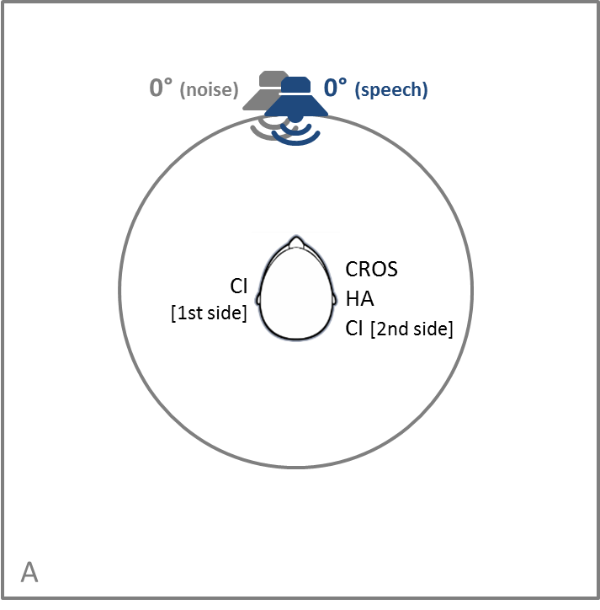 | 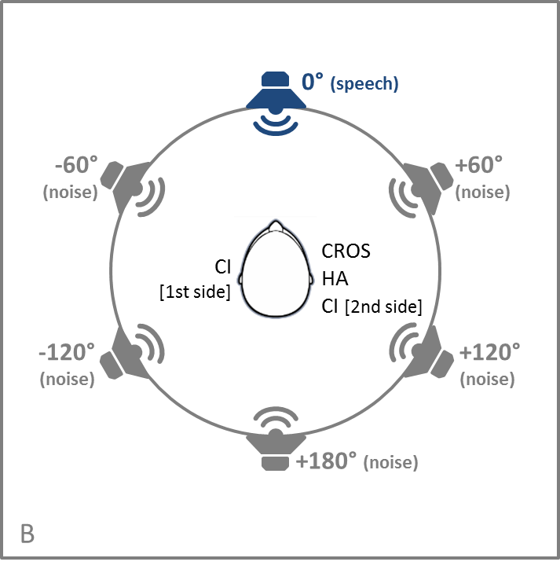
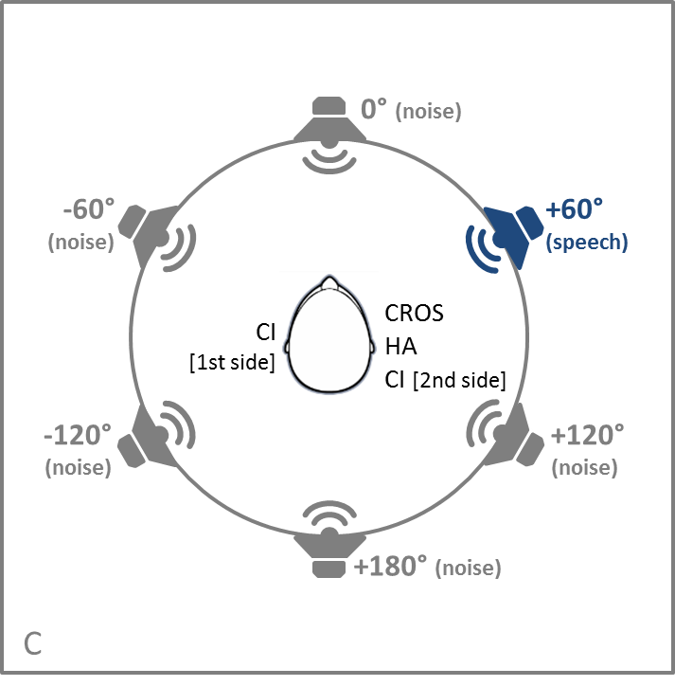 | 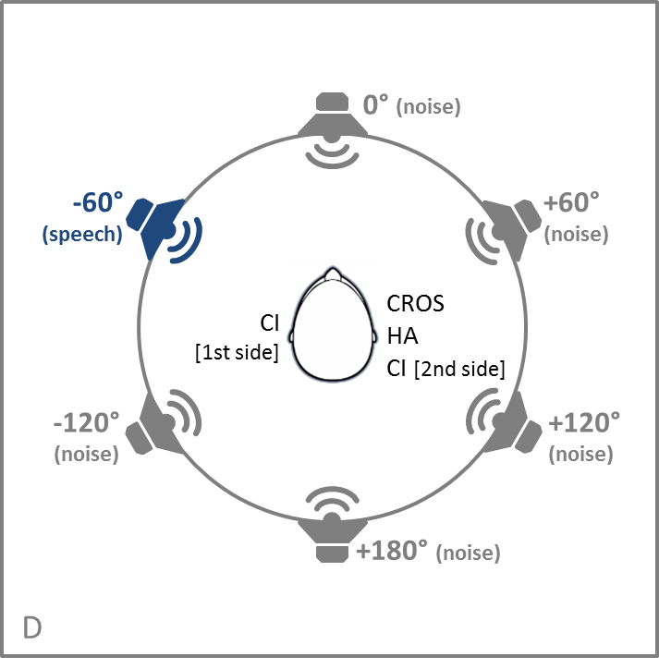
Figure 4: Loudspeaker setups for assessment of speech perception in quiet and noise. Setup A presenting the speech signal in quiet or speech and noise at the same time from one loudspeaker. Setups B - D presenting the speech signal from one loudspeaker (blue) and noise from five different loudspeakers (gray).

Localization Test
For the localization test seven loudspeakers are used positioned in a frontal semicircle (0°, ±30°, ±60°, ±90°) of 2 meter in diameter in the horizontal plane at the subject’s head level. Ten sentences from the Oldenburg sentence test are presented at five different intensity levels between 59 dB SPL and 71 dB SPL in a random sequence order of loudspeakers, i.e. 70 signals in total from seven loudspeakers.
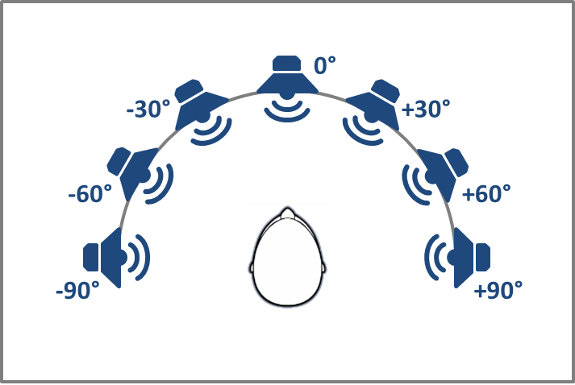 | Figure 5: Loudspeaker setup for localization assessment.
    - Fitting of Hearing Devices
The CI processor(s) will be fitted by the audiologist using the clinical fitting software SoundWave following standard fitting guidelines and procedures based on the subjects previously used programs. During appointment A, subjects receive a programming adapted to their individual preference in terms of speech coding strategy and front-end features (e.g. noise reduction algorithms or microphone settings). Subjects will use their own sound processor during the take-home phase.
The bilateral group will receive the same settings on both CI sound processors. For the unilateral group the loaner CROS device will be switched on within the CI processor fitting automatically applying the same microphone configurations as the CI sound processor.
The bimodal group will receive a loaner Naída Link HA in case the subjects are using a HA other than the Naída Link HA for the take-home trial. The hearing aid will be fitted by the audiologist using the clinical fitting software Target following standard fitting guidelines and procedures applying the bimodal fitting formula. Microphone settings and noise reduction algorithms of the hearing aid will be adapted to the CI sound processor settings.
For the study measurements, microphone settings will be programmed according to the respective configurations under investigation, while sound cleaning algorithms will be switched-off. The noise reduction algorithm ClearVoice will be used in the same configuration as in the subjects’ CI sound processor for all measurements. For short-term adaptation to the CROS device, the bilateral as well as the bimodal groups will receive a loaner CROS device after the first test session of appointment B.
The entire fitting equipment is CE marked and is in use in clinical standard procedures. For the measurements during the appointments, loaner Naída CI Q90 sound processors, Naída Link CROS devices and Naída Link hearing aids will be used for all subjects.
  - Study Objectives and Assessments
    - Study Primary Endpoint Assessment
The primary objective of this study is to compare the speech intelligibility with CI and the contralateral CROS device to the speech intelligibility with CI and unaided contralateral side in the presence of speech shaped noise in the unilateral CI group (described in section 2.5.8 Measures).
    - Study Secondary Endpoint Assessment
The secondary objectives of this study are:
- Comparison of different device configurations (CI only, CI + CROS, CI + HA, CI + CI) in terms of differences in speech intelligibility in quiet
- Comparison of different device configurations (CI only, CI + CROS, CI + HA, CI + CI) as well as different microphone options (omni, UltraZoom, StereoZoom) in terms of differences in speech intelligibility in stationary speech shaped noise
- Comparison of different device configurations (CI only, CI + CROS, CI + HA, CI + CI) in terms of differences in localization abilities.
    - Additional Interest Assessment
The outcomes for speech intelligibility and localization abilities will be compared between the different CI user groups as well as the normal hearing reference group.
Hearing thresholds will be compared between the different groups and correlated with the outcomes for the different device configurations.
Subjective feedback on experiences in terms of speech understanding and sound quality with the different devices will be evaluated via questionnaires during the appointments completed by the subject together with the audiologist.
  - Statistical Methods
    - General Considerations
The primary and secondary objectives of this study are related to various measures of speech intelligibility, localization and subjective preference regarding sound quality and speech understanding. For speech intelligibility tests in speech shaped noise, the outcome measures are speech reception thresholds (SRTs) obtained using the OLSA test, i.e. signal-to-noise ratios (expressed in dB) required to achieve 50% correct word recognition. Localization measurements will yield localization errors (expressed in degree).
    - Analyses
Data will be analyzed for differences between various device and processing options under investigation. Speech performance data as well as questionnaire data will be compared in addition to the baseline clinical configuration. Typical descriptive statistical methods will be used to estimate the means, medians, variances and confidence intervals of these differences.
Complications will be categorized and trended. Throughout the analysis, care will be taken to ensure complete anonymity of data and protection of the identity of all study subjects.
    - Sample Size Justification
A sample size of N = 10 per group was chosen based on efficacy considerations regarding the primary objective of this study, i.e. to demonstrate improved speech intelligibility in the presence of speech shaped noise using the device configuration CI and CROS compared to CI only (benefit of CROS device).
We consider a 3 dB benefit as clinical relevant. From previous clinical experience and literature we expect a standard deviation of 2 dB in CI users tested with the German OlSa sentence test. To remain on a conservative side, we choose to run the sample size calculation with ρ = 0.5. To detect a 3 dB effect size with those parameters at a 2-tailed significance level of 0.05 with a power of 0.95, we need to include 8 subjects.
The number of subjects was increased to N = 10 as a measure of precaution against type-2 errors in the face of remaining technical and methodological difference between the current study and the previous studies and the fact that meaningful subjective feedback should be collected via questionnaires as additional interest measurement, in general requiring a higher number of data sets.
In case of subjects terminating the study before completion, more than 10 subjects per group will be enrolled in the study (replacement of withdrawn subjects).
- Risk Analysis
Acute measurements will be conducted in the Universitätsklinikum Freiburg. The Oldenburg Sentence test (OlSa) will be used to measure the speech reception threshold (SRT). The OlSa is also used within the clinical routine. Uncomfortably loud stimuli will be avoided during this study. In case of an (unexpected) uncomfortable hearing sensation the study participant is able to stop the measurement at any time by disconnecting the headpiece. The cochlear implant sound processor as well as the hearing aid and CROS device will be programmed by using CE-certified software recommended by the manufacturer. All study participants are adults and have a minimum experience of six months with their implant system. There is a minor risk for altered situation awareness as well as bruises or unpleasant wearing impression. There is no known long-term risk associated with this study. All risks are similar to the risks in the clinical routine.
  - Adverse Event Reporting
An adverse event (AE) is defined as any untoward medical occurrence, unintended disease or injury, or untoward clinical signs (incl. abnormal laboratory findings) in subjects, users or other persons whether or not related to the investigational device.
A serious adverse event (SAE) is an event that leads to:
- Death due to any cause
- A life-threatening illness or injury
- A permanent impairment of a body structure or a body function
- In-subject hospitalization or prolongation of existing hospitalization
- Medical or surgical intervention to prevent permanent impairment to body structure or body function
- Fetal distress, fetal death, congenital abnormality or birth defect
An adverse device effect (ADE) is any untoward and unintended response to a medical device.
A serious adverse device effect (SADE) is an event that resulted in any of the consequences characteristic of a serious adverse event (SAE) or that might have led to any of the consequences if suitable action had not been taken or interventions had not been made or if circumstances had been less opportune.
An unanticipated adverse device effect (UADE) Is any serious adverse effect on health or safety; any life threatening problem or death caused by, or associated with, a device, if that effect, problem, or death was not previously identified in nature, severity, or degree of incidence in the investigational plan or application; or any other unanticipated serious problem associated with a device that relates to the rights, safety, or welfare of subjects.
All adverse events and adverse device effects, serious and non-serious, will be tracked during the course of the study using the appropriate case report form. Case report forms should include, but are not limited to:
- Description of event, duration, and severity
- Date that event was first detected (if after surgery)
- Course of action taken
- Status (resolved, improving, no change, worsening). The status of the event will be tracked throughout the study until it is resolved or the study is closed.
- Subject and device identification
The relationship between the study procedures and the incidence of an adverse event will be classified by the investigator in categories as divided in the CRF:
- Not related
- Related
- Unknown
Evaluation of any SAEs, SADEs, and UADEs will be conducted promptly. Confirmed SAEs, SADEs, and UADEs will be reported by the Sponsor to all ethics committees as soon as possible but in any case within 2 working days after receiving notice of the event. If it is determined that an event or effect presents an unreasonable risk to subjects, this study, or those parts of the study presenting that risk, will be terminated not later than 5 working days after the determination is made and not later than 15 working days after the Sponsor/Clinical Research first received notice of the effect (section 4.7).
All other issues related to the device will be reported to Advanced Bionics AG, as indicated in the product manuals.
- Ethical and Regulatory Responsibilities
  - Study Conduct
The Investigator must agree that the study will be conducted according to the protocol, the principles of ISO 14155:2011, 90/385/EEC, ICH-GCP, Declaration of Helsinki and internal Standard Operating Procedures (SOPs) and local regulations.
The Investigator will assure proper implementation and conduct of the study including those study-related duties delegated to other appropriately qualified individuals and designated on the Investigator Signature Page. The Investigator will assure that study personnel cooperate with monitoring and audits, and will demonstrate due diligence in recruiting and retaining study subjects.
  - Ethical committee
Before initiation of the study, the Investigator must obtain approval of the CIP and the ICF from the governing EC in compliance with the provisions specified by ISO 14155:2011. The Investigator is responsible for assuring compliance of the EC with applicable regulations. A copy of the written EC approval of the CIP and the ICF, EC application materials, and recruitment advertising (if applicable) must be provided to the Sponsor prior to initiation of the study. The approval letter must be signed by the EC chairman or designee, specify the EC name and address, identify the CIP by title and/or protocol number, and include the date that approval was granted. The Investigator is responsible for obtaining continued review of the study at intervals not exceeding one year or as otherwise specified by the EC. The Investigator must provide the Sponsor with written documentation of the review and materials submitted to the EC for continuing approval. Investigators must notify the EC promptly regarding all SAEs that occur at their site, in accordance with local reporting policy.

  - Informed Consent
    - Informed Consent Form
The Informed Consent Form must be provided to the Sponsor for approval prior to submission to the EC. The Sponsor will provide an informed consent template and assistance in adapting that template to conform to local requirements. Before enrollment, the study will be explained to each prospective study candidate. Candidates will be asked to read the approved ICF and given the opportunity to ask questions. Once all questions have been answered and the Investigator is assured that the individual understands the implications of participating in the study, the subject will be asked to sign the ICF. Each subject must get ample time to consider participation in the trial. The Investigator will provide a copy of the signed ICF to each subject. If an amendment to the protocol changes the scope or activities associated with a subject’s participation, or increases the potential risk to the subject, the ICF must be revised and submitted to the EC for review and approval. The revised ICF must be used to obtain consent from a subject currently enrolled in the study if he or she is affected by the amendment. The revised ICF must be used to obtain consent from any new subject who is enrolled in the study after the date of the approval of the amendment. Any modification of the consent, e.g. subject information made by an investigator has to be authorized by the Sponsor before it is sent to the EC.
    - Subject Enrollment
An individual is considered to be enrolled as a study subject only after the ICF has been signed. Each subject will get ample time to consider participation in the trial. Once enrolled, the subject will be assigned a unique identifier. The identifier will consist of an alphanumeric sequence that will consist of: a study identifier, the investigational site identifier and the sequential subject number, e.g. UKF-CROS-09 for subject 09 at the center UKF in the CROS study.
The normal hearing reference group will sign a data release form before participation in the study. They will be tracked with the same identifiers as the CI subjects.
  - Amendments and Deviations
    - Protocol Amendments
The protocol must be followed exactly. Any changes to the protocol must be implemented through a formal protocol amendment. Amendments to the protocol must be initiated by the Sponsor or at the request of other parties. In either case, a formal amendment cannot be initiated until it has been approved by the Sponsor, the Investigator, regulatory agencies (if applicable), and the EC. It can only be altered by written approved amendments by the CPM. Administrative changes that do not affect the subject risk ratio may be made after consulting AB AG.
    - Emergency Deviations
Emergency deviations or modifications must be reported to the Sponsor and the EC no later than 24 hours after the emergency.
Study Management accepts the right of the investigator to deviate from protocol in a medical emergency when necessary to safeguard the life or physical wellbeing of the subject. The following conditions must apply for a situation to be considered a medical emergency:
- The subject is in a life threatening situation and needs immediate treatment.
- No generally acceptable alternative for treating the subject is available.
- Time does not allow the investigator to notify the Sponsor to obtain regulatory approval.
In these cases the investigator is obliged to notify the CPM immediately who will notify the EC and Regulatory agencies no later than 5 working days after the event was reported.
  - Documents and Records
    - Pre-Study Documentation Requirements
Prior to obtaining consent from any subjects, the following documents must be provided to Advanced Bionics:
- A copy of the protocol signature page and investigator agreement, signed and dated by the Principal Investigator and Co-Principal Investigator(s), if applicable
- A signed and dated copy of the Clinical Study Agreement
- A copy of the written EC approval of the protocol
- A copy of the approved ICF and written EC approval of the form
- A copy of the curriculum vitae of the Principal Investigator and Co-Principal Investigator(s), if applicable
    - Study Documentation/Case Report Forms
Data must be submitted according to protocol requirements for all enrolled subjects. CRFs provided for this study must be used to submit data to the Sponsor. Each subject will be assigned a unique identifier at the time of enrollment (as described above), which will be used on all CRFs.
Study records are comprised of monitored CRFs, and all other administrative documents including, for example, EC correspondence, clinical trial materials and supplies shipment manifests, monitoring logs, and correspondence with the Sponsor. A study-specific binder will be provided with instructions for maintenance of study records.
Source documentation is defined as any hand-written or computer-generated document that contains medical information or test results that have been collected for or are in support of the protocol specifications. For example, these documents may include audiograms, results from CT scans and x-rays, lab reports, clinic notes, subject questionnaires, and telephone logs. All draft, preliminary, and pre-final versions of a report also are considered source documents, including faxed reports or data and hard copies of test results.
    - Protocol Deviations
Deviations from the clinical protocol and protocol requirements including GCP and ISO14155:2011 guidelines will be reviewed and evaluated at each monitoring visit.
Appropriate corrective actions will be implemented as necessary. Each and every deviation from the protocol requirements and European standard ISO 14155:2011 ‘clinical investigation of medical devices’ will have to be reported as ‘Protocol Deviation’.
A very serious deviation that affects the scientific soundness of the study or any aspect of the subject’s safety, rights or wellbeing may be a cause to close the study at an investigational center. In addition, these very serious deviations will require urgent reporting to ECs and data management.
  - Study Monitoring
A clinical research monitor will supervise conduct of the study at each site. The monitor will visit the Investigator and the study facility at periodic intervals in addition to maintaining ongoing telephone, e-mail, and letter contact. The monitor will maintain up-to-date personal knowledge of the study through observation, review of study records and source documentation, and discussion of the study with the Investigator and study personnel.
The Sponsor’s internal auditors or contract auditors may evaluate the conduct of the study at a site. These parties will have access to all study-related documents. The Sponsor audit reports are confidential and proprietary.
    - Device Accountability
As all the products that are used in this study are commercially available on the CE market the only accountability that we will do is to track the serial numbers of loaner devices provided to the subjects during the study. Devices are not labeled differently than those that will be used for subjects who do not participate in the study.
    - Record Retention
All study records (e.g., protocol, correspondence with the Sponsor and the EC , EC approvals, CRFs, subject records, consent forms, reports) must be maintained by the Investigator until notified by the Sponsor and at least as long as local document retention regulations require. If an Investigator opts to discontinue participation in the study, all records will be transferred to a mutually agreed designee (i.e., another Investigator).
This transfer is subject to the Sponsor’s approval and will be documented in writing with copies sent to the sponsor. If an Investigator leaves the site at which the study was conducted, the Sponsor should be contacted regarding the disposition of documents.
    - Inspection of Records
In the event of an audit, the Investigator agrees to allow representatives of the Sponsor or other regulatory authorities to access all study records. The Investigator will notify the Sponsor promptly of all audit requests from government or other regulatory agencies and will promptly forward a copy of all audit findings to the Sponsor.
  - Suspension and Termination
    - Criteria for Suspending or Terminating a Study Site
After the study begins, the Sponsor reserves the right to terminate enrollment of subjects at a study center at any time if (1) no subjects have been enrolled, (2) the center has multiple or severe unjustified protocol deviations, or (3) the center fails to follow remedial actions for protocol deviations.
Possible reasons for suspending or terminating a center include:
- Investigator non-compliance.
- Repeated failure to complete or submit CRFs in a timely manner.
- Failure to obtain written informed consent from each subject.
- Failure to report an SAE or UADE to the Sponsor within the required timeframe.
  - Investigator Responsibilities
By selecting investigators who are experienced and skilled in the fitting of CI sound processors, hearing aids and CROS devices and procedure efforts, the risk for subjects is minimized. The selection of principle investigators and investigators will be conducted to the international harmonized standards and general operation procedures.
Only appropriate subjects can be enrolled in the study, adhering to the clearly defined inclusion and exclusion criteria which limit participation to those subjects who qualify for the use of cochlear implant technology and the requirements stipulated in this protocol. The treatment and follow up of the subjects outlined in the study protocol is consistent with current GCP and the Declaration of Helsinki as set forward in the ISO 14155:2011.
Each subject will be assigned a unique identifier at the time of consent to protect subject confidentiality.
Investigators participating in this study must agree:
- To sign and adhere to the protocol and the Clinical Study Agreement
- To provide a signed and dated copy of their curriculum vitae
- To obtain EC approval of the study protocol and secure continuing review and approval of the study until it is closed
- To conduct the investigation in accordance with the study protocol, Clinical Trial Agreement, all applicable regulations, and conditions of approval imposed by the reviewing EC or regulatory agencies
- To supervise all testing of human subjects
- Ensure that all subjects are properly consented
- Not to release any details of the study without the prior written consent of the Sponsor
- To adhere to terms of publications and presentations from the study in accordance with the terms of the Clinical Study Agreement
- Estimated time needed to select number subjects (i.e. enrolment period)
- Monitoring Procedures
All investigators and investigational sites will be monitored on a continuing basis, through the course of the clinical study to oversee compliance with the regulatory and clinical aspects of the study. A Clinical Monitor will maintain current personal knowledge of the study through observation, review of study records and source documentation, and discuss and update study related issued with the investigators and study site staff. Clinical Monitors will be certified and members of AB AG.
  - Site Initiation Training
The following information is reviewed and discussed during site initiation training:
- Good Clinical Practice, including investigator responsibilities and purpose of monitoring activities
- Requirements for EC approval (initial application and continuing reviews)
- Informed consent procedures, including requirements for inclusion of all foreseeable risks in the ICF
- Study protocol and procedures
- Processes for recording and reporting adverse events
- Device accountability procedures
- Data collection and correction procedures, source documentation, and record retention requirements
  - Interim Monitoring Activities
The Clinical Monitor will perform at least the following activities during on-site visits:
- Confirm that the facilities continue to be appropriate and that the study records are stored in a secure location
- Conduct review and collection of regulatory documents
- Review subject ICFs for completeness and accuracy
- Confirm that the study protocol is being followed and that any changes in the protocol have been reported to the EC and Advanced Bionics, as applicable
- Review CRFs and source documents for completeness, accuracy, and timely submission to the Sponsor
- Verify that all adverse events have been reported to the Sponsor within the appropriate timeframe. If an event is discovered that requires reporting, the Clinical Monitor will instruct the investigators to document the event on the appropriate CRF and submit to the Sponsor within the required timeframe
- Review and resolve data clarification requests, if appropriate
- Review device accountability records
- Follow up on outstanding monitoring visit action items
At the end of the visit, the Clinical Monitor will meet with the investigators to review site compliance with the protocol, investigator responsibilities, and applicable regulations.
  - Close-Out Monitoring Activities
The Clinical Monitor performs at least the following activities during study close out:
- Conduct review and collection of regulatory documents
- Resolve open data clarification requests
- Review study file retention and storage requirements
- Collect outstanding CRFs
- Review investigator responsibilities including EC notification of study closure
- Follow up on any outstanding issues, including unresolved adverse events.
- Review the potential of regulatory or Sponsor audits
At the end of the visit, the Clinical Monitor will meet with the investigators to review site compliance with the protocol, investigator responsibilities, and applicable regulations.
  - Management of Site Noncompliance
Noncompliance with the signed agreement, the CIP, regulatory requirements, or any conditions of approval imposed by the EC will be addressed by re-training the investigators on the appropriate study procedures and documenting the re-training. Continued noncompliance may result in termination of study participation.
In the event of site termination and the use of investigational product, the Sponsor will stop shipping investigational product and request that any investigational product at the site be returned.
  - Documentation and Records
The Sponsor and investigators maintain files with Ethical committee and regulatory documents. CRFs are completed for each study subject. The Sponsor maintains the original CRFs and the study site retains copies of all CRFs. The Clinical Monitor documents monitoring activities and prepares a report after each monitoring visit.

- Data Management
  - Data collection
CRFs will be used to collect all subject data during the study. CRFs must be fully completed for each subject, signed and dated and available for review by the Clinical Monitor who will work under ICH-GCP rule.
The investigators or the authorized study personnel are required to sign the CRF pages where needed to validate they have read and are in agreement with the reported data.
  - Data processing
The investigator or designated individual is responsible for recording all data from the trial on the CRFs supplied by the Sponsor. The data reported in the CRF must be unambiguous.
Development of the primary database and subsequent data entry for the trial will be performed by the Sponsor. The person responsible for data management must confirm the overall integrity of the data.
- Contractual binding documents
By signing the study protocol, the investigator agrees to keep all information made available to him/her in strict confidence and ensures the same level of confidentiality from his/her staff.
The study documents (study protocol, CRFs and other materials) made available by/to the principal investigators need to be stored adequately in order to assure their confidentiality in the hospital for a duration of 25 years.
The information made available to study hospital personnel must not be passed on to others without written authorization of the Sponsor.
- Publication
The study will be published in peer reviewed journals. Any manuscript or presentation concerning this study must be provided to AB AG minimum 30 working days before planned publications for in depth reviewing. The Sponsor will not have a veto. However, publishing can only be undertaken after a unified written agreement between the researchers has been reached and the review by the sponsor finds accordance between the calculated and reported data. In any case, the major-first publication will be a co-authorship reporting all data gathered in this study (i.e. all sites).
- References
Bentler RA, Palmer C, Dittberner AB (2004). Hearing-in-Noise: comparison of listeners with normal and (aided) impaired hearing. J Am Acad Audiol, 15:216-225.
Brown KD, Balkany TJ (2007). Benefits of bilateral cochlear implantation: a review. Curr Opin Otolaryngol Head Neck Surg, 15:315-8.
Buechner A, Frohne-Buechner C, Gaertner L, Lesinski-Schiedat A, Battmer RD, Lenarz T (2005). The Usefulness of a Pinna Microphone Position for Soundlocalisation in Bilateral Cochlear Implant Users. Auditory Research Bulletin, Biennial Edition of Advanced Bionics.
Dillon H (2012). Hearing Aids, Thieme, New York.
Geissler G, Arweiler I, Hehrmann P, Lenarz T, Hamacher V, Buechner A (2015). Speech reception threshold benefits in cochlear implant users with an adaptive beamformer in real life situations. Cochlear Implants Int, 16:69-76.
Litovsky R, Johnstone P, Godar S (2006). Benefits of bilateral cochlear implants and/or hearing aids in children. Int J Audiol, 45 Suppl 1:S78-91.
Ricketts T, Henry P (2002). Evaluation of an adaptive, directional-microphone hearing aid. Int J Audiol, 41:100-112.
Summerfield QA, Marshall D, Barton G (2002). A cost-utility scenario analysis of bilateral cochlear implantation. Arch Otolaryngol Head Neck Surg, 128:1255-62.
Summerfield QA, Barton GR, Toner J, McAnallen C, Proops D, Harries C (2006). Self-reported benefits from successive bilateral cochlear implantation in post-lingually deafened adults: randomised controlled trial Int J Audiol, 45 Suppl 1:S99-107.
Taal CH, van Barneveld DCPBM, Soede W, Briaire JJ, Frijns JHM (2016). Benefit of contralateral routing of signals for unilateral cochlear implant users. J Acoust Soc Am, 140:393.
van Hoesel R, Boehm M, Pesch J (2008). Binaural speech unmasking and localization in noise with bilateral cochlear implants using envelope and fine-timing based strategies. J Acoust Soc Am, 123:2249-63.
Wagener K, Kuehnel V, Kollmeier B (1999). Entwicklung und Evaluation eines Satztests fuer die deutsche Sprache. I. Design des Oldenburger Satztests. Z Audiol, 38:4-15.

-End Of Document-

